1. In all the exercises below (so exercises 1, 2, 3, and 4) we start out with the Black-
Scholes market, i.e. a market consisting of a risk free asset, B, with P-dynamics given by

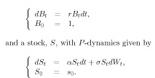

Here W denotes a P-Wiener process and r, _ and _ are assumed to be constants.
(a) Compute the price of a European call option written on a non-dividend-paying stock. The current stock price is $100 and the volatility of the stock price is 20%. The maturity of the option is in six months and the strike price is $100. The risk free interest rate with continuous compounding is 3% per annum.

(b) Same as exercise 1a except now the underlying stock will pay a dividend of $5 in four months time.

(c) Again, same as exercise 1a except now the underlying stock is really a stock index paying a continuous dividend yield of 5%.

2. (a) Compute the price of a European call option written on a futures contract. The strike price of the option and the current futures price are both $100 and the time to maturity of the option is six months. The risk free interest rate with continuous compounding is 3% and the volatility of the futures price is 20%.
(b) State put-call parity for futures options and use it to compute the price of the put option corresponding to the call option in exercise 2a.

3. Suppose that the following parameters have been estimated for the Black-Scholes model:
α = 0.08, σ = 0.2, and r = 0.05. Furthermore suppose that at time t = 0 you sell a European call option on the stock with strike price K = 108 and exercise date T = 1 year. Your task is to evaluate the performance of a delta hedge for this short position in the option. More precisely, if you sell the option and hedge the position using delta hedging as described below, will you have lost or gained money at time t = 1? The hedge should be rebalanced every four months (i.e. at t = 1/3 year and so on). Furthermore, the hedge should be set up at time t = 0 in such a way that the value of the total portfolio is zero, and the rebalancing should be performed in a self financing manner. Below you find the necessary data to compute the hedge.
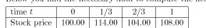

Make sure to explain how you obtain your numbers!

4. Suppose that you for some reason are fairly certain that the stock price will not move much until time T. In fact you are so certain of this you are willing to bet on it. Thus you would like to enter a butterfly spread, which is a T-contract with the payoff structure depicted in the figure below.

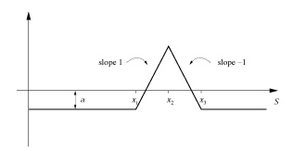

A natural choice for x2 is today’s stock price St and given that you have no information about whether a rise in the stock price is more likely than a fall you would set x2 = (x1 + x3)/2. How narrow you want the interval [x1, x3] depends on how sure you are that the stock price will not move. For this exercise set x1 = 0.95St. Now suppose that you do not have much money at the moment, and therefore would not want to pay anything entering the contract. Determine how much you must be willing to loose at most, i.e. the constant a, if you do not want to pay anything for the contract today (at time t). The expression derived for a should be given only in terms of the parameters of the problem, but it may contain the density or distribution function for the
N(0, 1)-distribution.

